bottle and pallet spec EU

Bottle material | I’m Green PE – plant-based HDPE derived from sugar cane
Contents | Still water
Volume | 500ml
Diameter bottle | 60mm
Height bottle | 230mm
Weight bottle | 538gr (filled)
Place of bottling | Manchester – United Kingdom
Dishwasher safe | Yes (up to 40C)
Reusable | Yes
Recyclable | Yes – with conventional plastics
Case size | 12 x 500ml
Case weight | 6,6 KG
Case dimensions | 249x185x227mm
Cases per pallet | 114
Layers per pallet | 6
Pallet weight | 760kg
Pallet Dimensions (Euro) | 1200x800x1506mm
Storage conditions | Store in a cool dry place, out of direct sunlight.

Water
Typical Analysis at source | Mg / litre
pH | 7.7
Calcium (CA) | 37
Magnesium (Mg) | 8
Sodium (Na) | 9
Chloride (Cl) | 17
Sulphate (SO4) | 13
Nitrate (NO3) | 4
Bicarbonates | 155

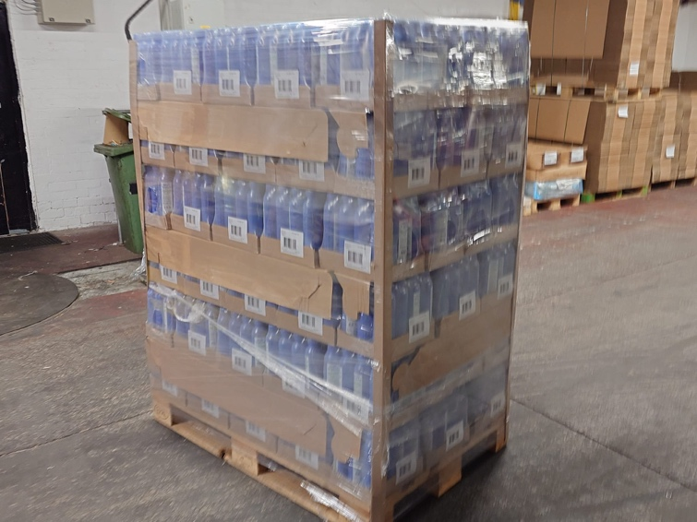

Pallet configuration: 6 layers of 19 cases
